# **Name: Abdurrahman Qureshi**

# **Roll No: 210451**

Practical No: 4

**1) WAP in java to check if the entered character is vowel or not**

**CODE:**

import java.util.*;

public class EXP4VowelCheck {

public static void main(String args[]){

Scanner sc = new Scanner(System.in);

System.out.println("Enter any character");

char ch = sc.next().charAt(0);

switch(ch) {

case 'A','a' :

System.out.println(ch + " is vowel");

case 'E','e':

System.out.println(ch + " is vowel");

case 'I','i':

System.out.println(ch + " is vowel");

case 'O','o':

System.out.println(ch + " is vowel");

case 'U','u':

System.out.println(ch + " is vowel");

break;

default:

System.out.println(ch + " is either a consonant, special character or a number.");

break; }}}

**OUTPUT:**

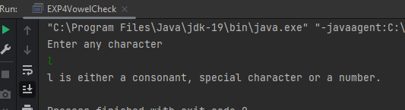

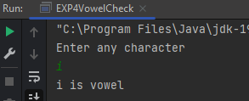

**2) WAP in java to use ternary operator**

**CODE:**

import java.util.*;

public class EXP4TernaryOperator {

public static void main(String[] args) {

Scanner scanner = new Scanner(System.in);

System.out.println("Which year is it?");

int flag = 0;

boolean con=true;

int year = scanner.nextInt();

String s = (year%4 == 0) ? "it is a leap year" : "it is not a leap year";

System.out.println(s); }}  
**OUTPUT:**

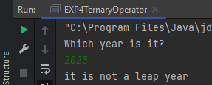

**3) WAP in java to use ternary operator to check even or odd**

**CODE:**

import java.util.*;

public class EXP4oddEvenTernary{

public static void main(String[] args) {

Scanner sc = new Scanner(System.in);

System.out.println("Enter the no " );

int a = sc.nextInt();

String statement = (a%2 == 0 )? " it is even '" : " it is odd" ;

System.out.println(statement); }}

**OUTPUT:**

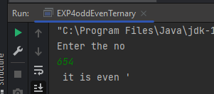 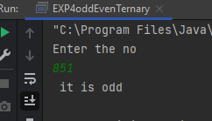

**4) WAP in java to use ternary operator to greatest of three**

**CODE:**

import java.util.Scanner;

import java.util.*;

public class EXP4GreatestOfThreeTernary {

public static void main(String[] args) {

Scanner sc = new Scanner(System.in);

System.out.println("Enter the first no ");

int n1 = sc.nextInt();

System.out.println("Enter the second no ");

int n2 = sc.nextInt();

String state = ( n1 > n2 ? n1 + " is greatest " : n2 + " is greatest");

System.out.println(state); }}

**OUTPUT:**

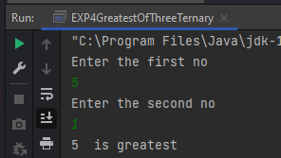

**5) WAP in java to use switch case with arithmetic menu**

**CODE:**

import java.util.*;

class EXP4ArithmeticMenu

{

public static void main(String args[])

{

Scanner sc = new Scanner(System.in);

System.out.print("Enter operator:");

char op = sc.next().charAt(0);

System.out.print("Enter operand 1:");

int x = sc.nextInt();

System.out.print("Enter operand 2:");

int y = sc.nextInt();

switch(op)

{

case '+':

System.out.print("Operand 1 + Operand 2 = " + (x + y));

break;

case '-':

System.out.print("Operand 1 - Operand 2 = " + (x - y));

break;

case '/':

System.out.print("Operand 1 / Operand 2 = " + (x / y));

break;

case '*':

System.out.print("Operand 1 * Operand 2 = " + (x * y));

break;

default:

System.out.print("Invalid operator...");

break;

}

}

}

**OUTPUT:**

